In this guide, we will be using AWS Free tier to setup and SSH into a Linux Ubuntu server. Keep in mind that AWS Free tier only lasts for 1 year. After this, you will start getting charged for any running instances.

**Prerequisites:**

* AWS account with attached payment information
* PuTTY and PuTTYgen. Download can be found at [https://www.PuTTY.org](https://www.putty.org) (you will be navigated to a different site to download it, but it is safe )

**Time needed: 1 hour**

1. Create AWS account
   * Navigate to <https://aws.amazon.com>
   * Click on My Account at the top and Choose ‘AWS Management Console’
   * Hover over Services and select EC2

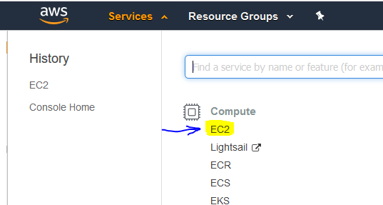

1. Click on ‘Launch Instance’

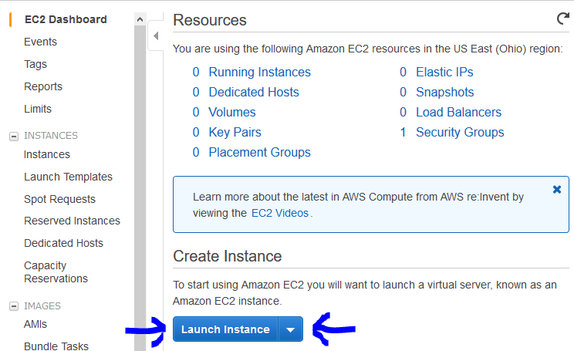

3) Type ‘ubuntu’ in the search bar and then select the Ubuntu Server 18.04 (Free tier eligible)

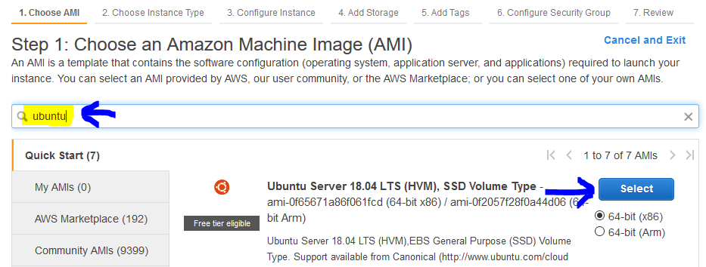

4) The Free tier option should be chosen by default. Click Next: Configure Instance Details

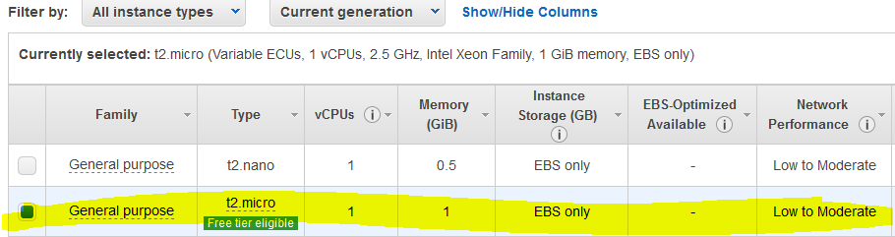

5) Configure Instance: No need to change anything here. Click Next: Add Storage

6)

* You currently get 30GB of storage on free tier. Since you can only have one EC2 instance running 24/7 for free, I choose to change this from 8GB to 30GB.
* Click Next: Add Tags

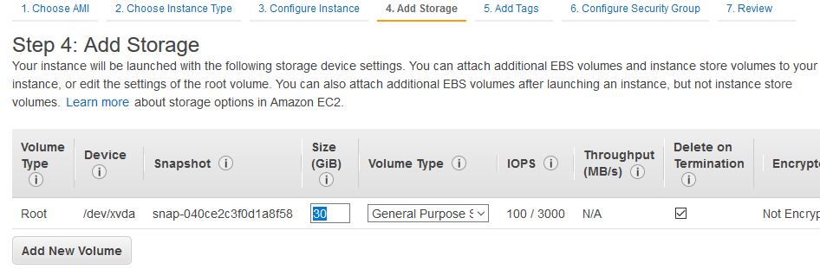

7) Click Next: Configure Security Group. Click ‘Add Rule’ button and input 25565 in ‘Port Range’ and change ‘Source’ to ‘Anywhere’

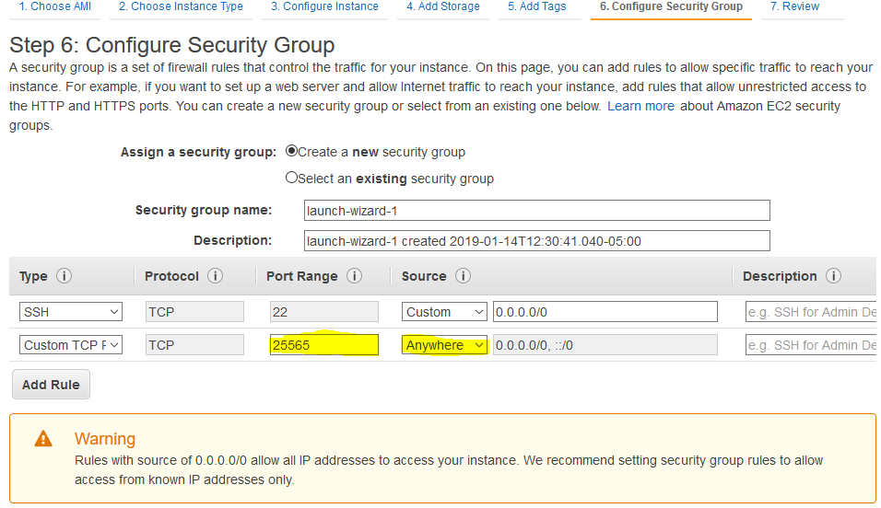

8) Click Review and Launch

* Verify everything is correct
* Click ‘Launch’. You will get the screen below
* Select ‘Create a new key pair’ and name it whatever you want
* Click Download Key Pair and save it somewhere you can access it
* Click Launch Instances
* Click View Instances

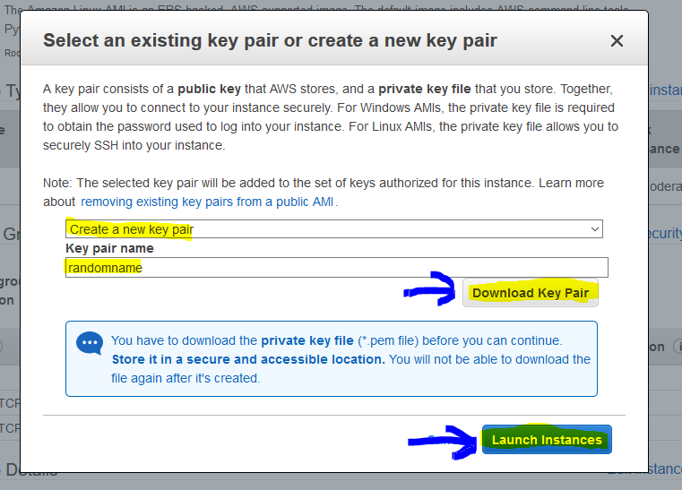

**SSH To Instance:**

**The following steps 9 & 10 are for Windows users only. If you aren’t using Windows or prefer a different guide, check out Amazon’s guides here: https://docs.aws.amazon.com/AWSEC2/latest/UserGuide/AccessingInstances.html

9) Open PuTTYgen.exe

* Click ‘Load’ and navigate to the folder where you downloaded the Key Pair to
* If using Windows, make sure select ‘All Files’ in the bottom right in order to see your key
* Choose your key and click ‘Open’. You should get message “Successfully imported foreign key…”

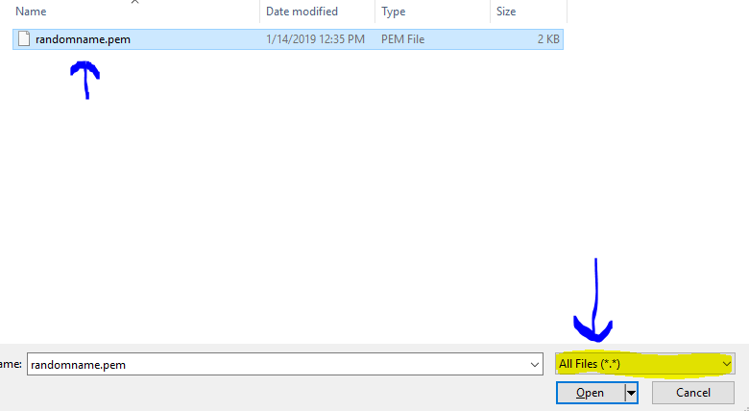

* Now click ‘Save private key’. You can add a passphrase if you want, but I usually don’t. If you are worried about someone getting their hands on your key, then you should add a passphrase.

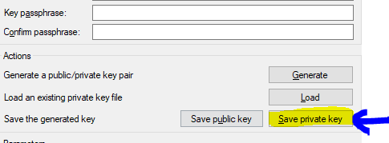

* Name this new key. I usually use the same name as the .pem file. This file should save as a .ppk
* Click Save

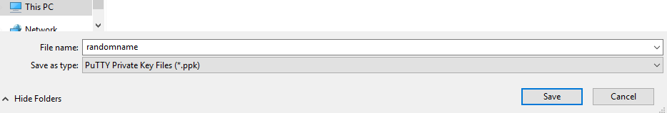

10) Open PuTTY.exe

* Expand ‘SSH’ towards the bottom. Then click on ‘Auth’
* On the right hand side, click ‘Browse’, and select your newly created .ppk key file
* Scroll back up to the top of PuTTY and click on ‘Session’.
* Go back to your browser where we created the Ubuntu server on aws, and locate the instance we just created (Services >> EC2 >> Instances (or ‘Running instances’)) . You should see your instance here, and what we are looking for is the Public DNS. Copy this field, starting with ‘ec2’ and ending with ‘.com’ which should look similar to the below picture



* Tab back to PuTTY. In the ‘Host Name (or IP address)’ box , paste the DNS. Then, prepend ‘ubuntu@’ to the DNS. So, if your DNS is ec2-1-2-3-4.us-east-2.compute.amazonaws.com, your box should look like ubuntu@ec2-1-2-3-4.us-east-2.compute.amazonaws.com
* You can save this config for future use by giving it a name under ‘Saved Sessions” and clicking Save (shown below)
* Finally, click Open

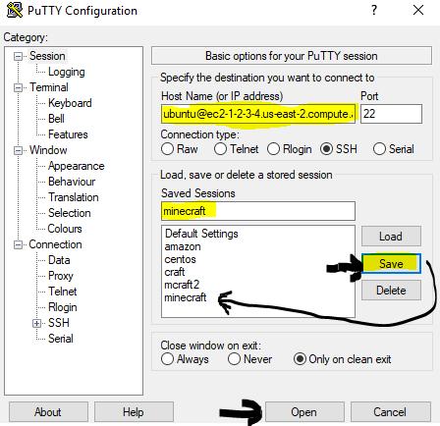

* You will receive the below security alert. Click ‘Yes’

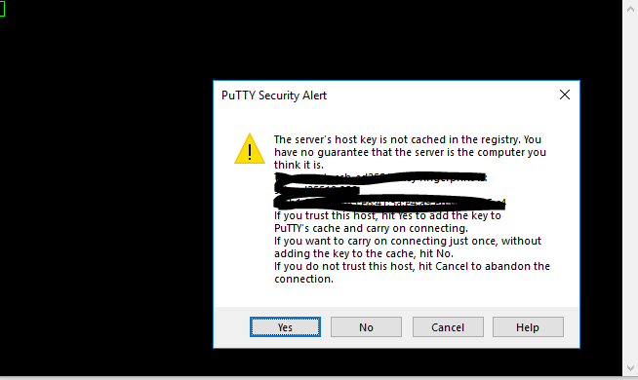

* For more info on connecting to your server instance from Windows using PuTTY, check out Amazon’s guide here <https://docs.aws.amazon.com/AWSEC2/latest/UserGuide/putty.html>

By now you should be connected to your server. If you had any issues following this guide, try looking at Amazon’s User Guide here: <https://docs.aws.amazon.com/AWSEC2/latest/UserGuide/AccessingInstancesLinux.html>